The tableau HR scorecard

Measuring success in talent management

**1 INTRODUCTION**

**1.1 Overview**

*The Tableau HR Scorecard is a framework designed to measure and evaluate the success of talent management strategies within an organization. It provides a way for HR professionals and business leaders to track and analyze key performance indicators (KPIs) related to workforce planning, recruitment, and development.*

**1.2 Purpose**

*The HR scorecard is a tool that*

*Helps measure, manage and improve the role of the HR funcntion within an organization.*

*HR metrics and KPIs or HR deliverables are measured using the HR scorecard. This data is also to predict the potential growth of the organization.*

**2 Problem definition & Design Thinking**

**2.1 Empathy Map**

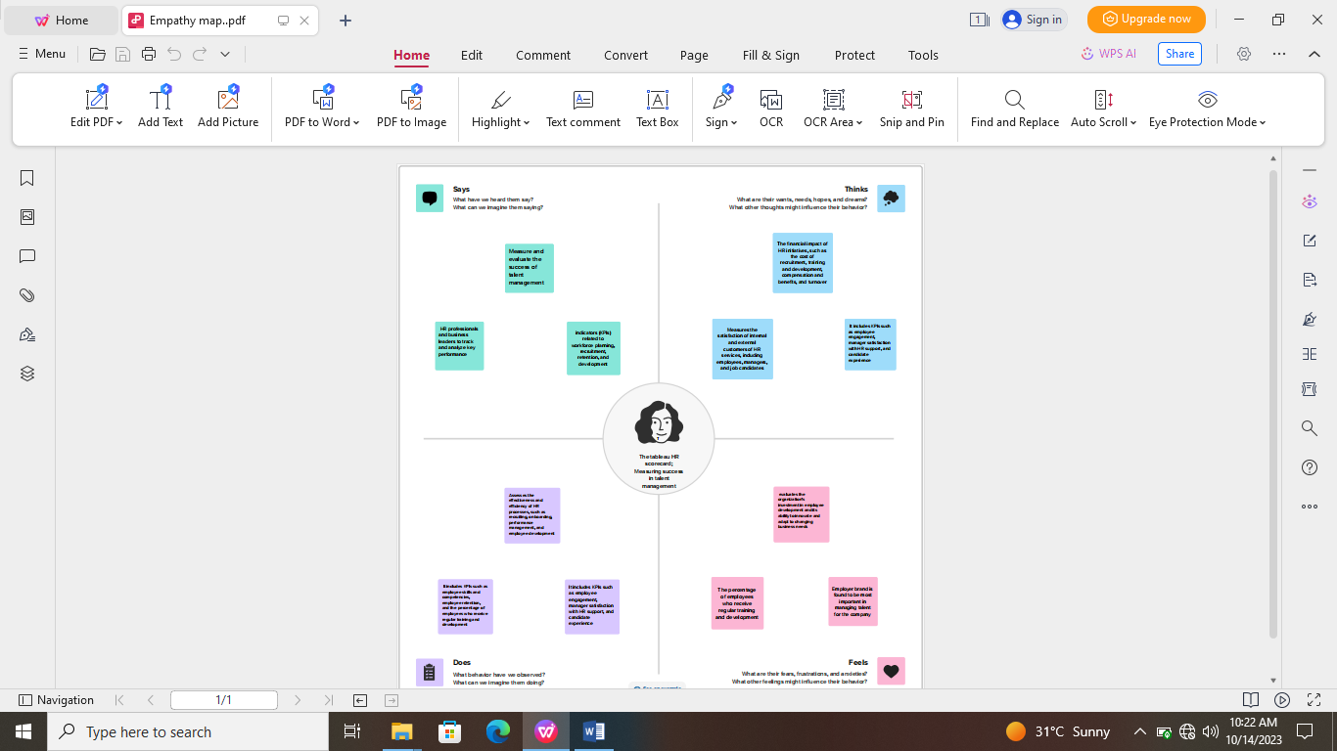

**2.2 Brainstorming map**

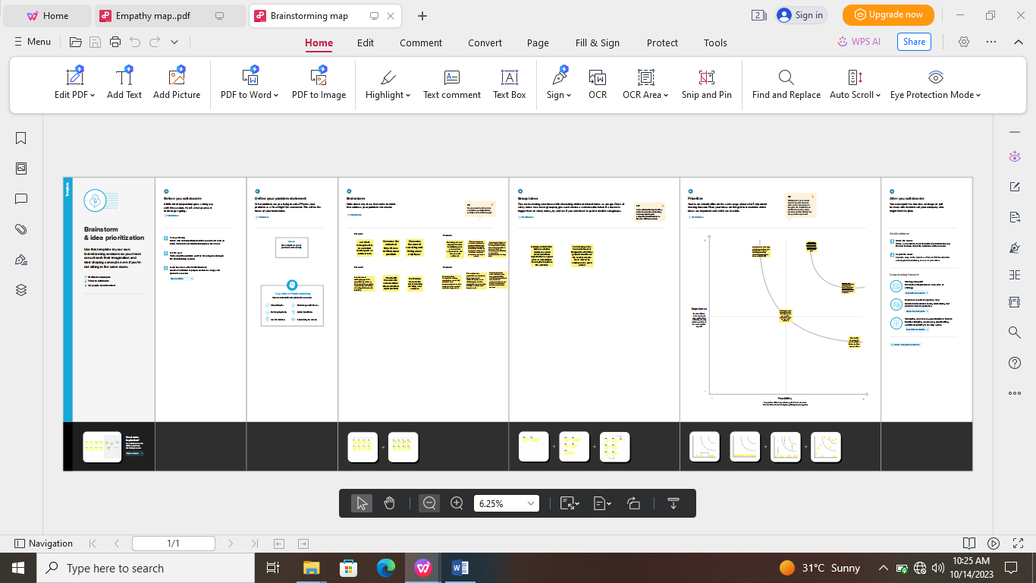

**3 RESULT**

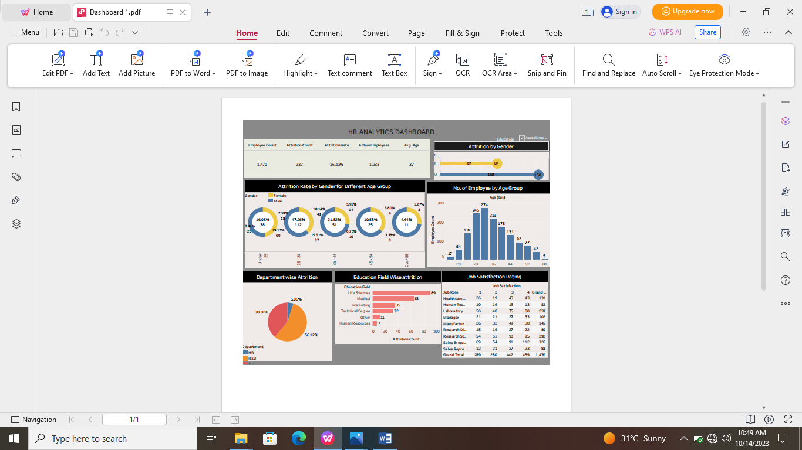

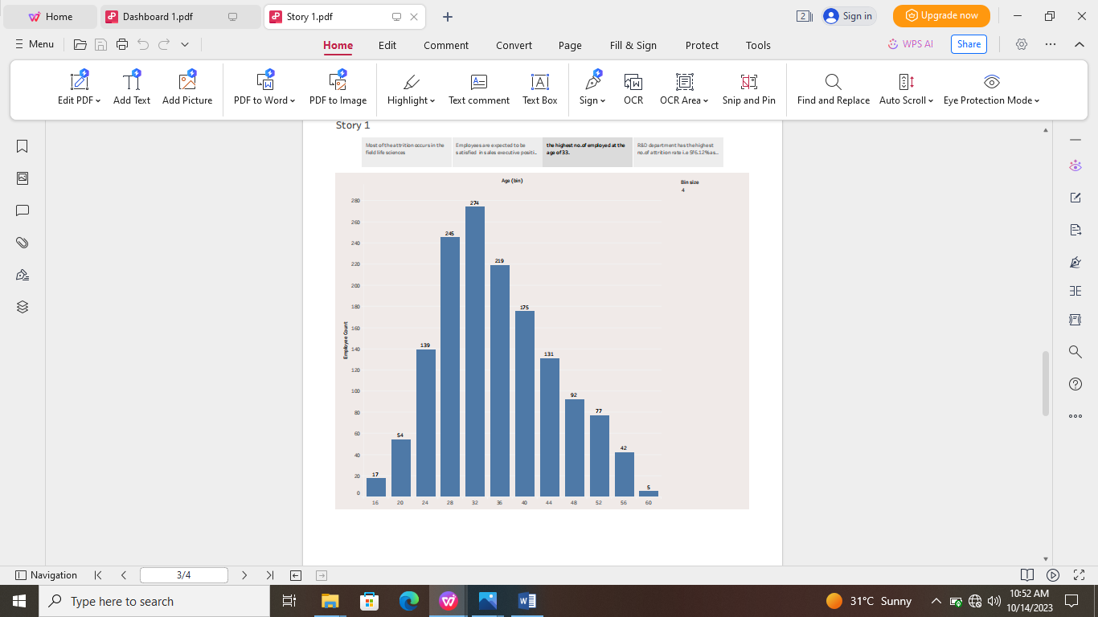

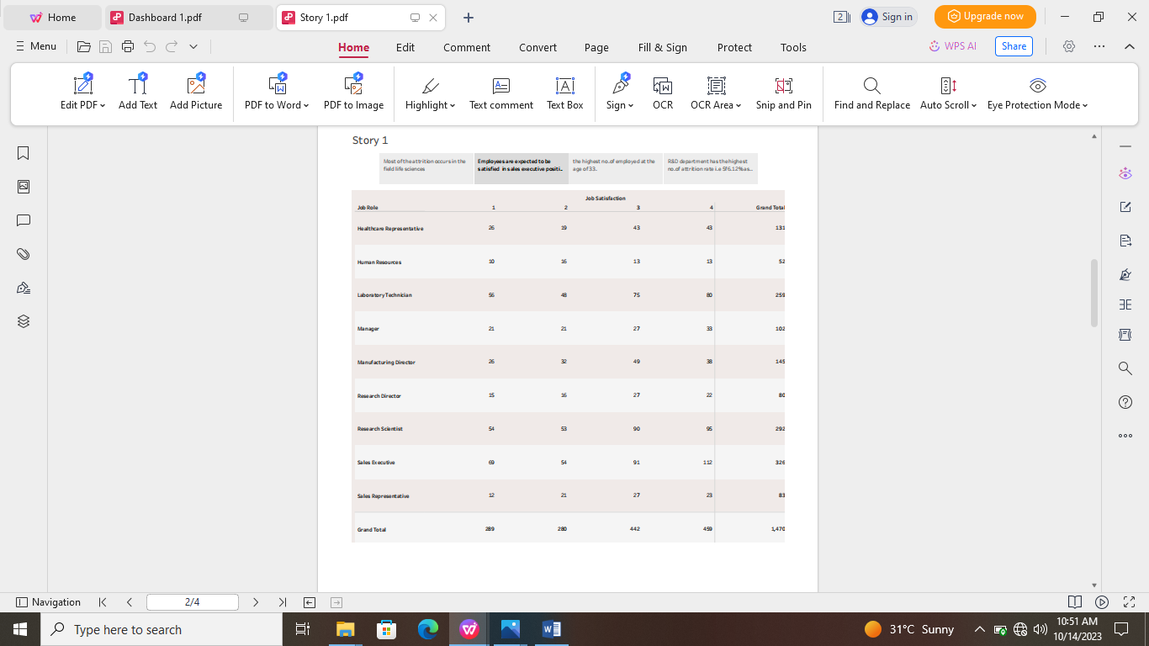

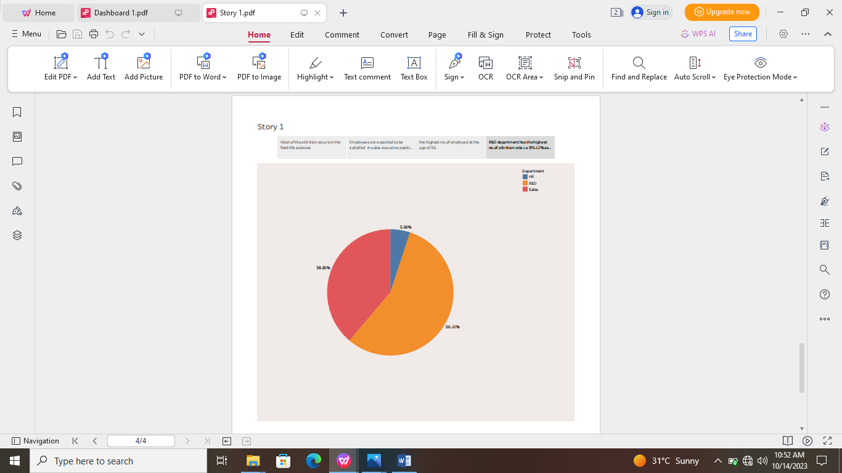

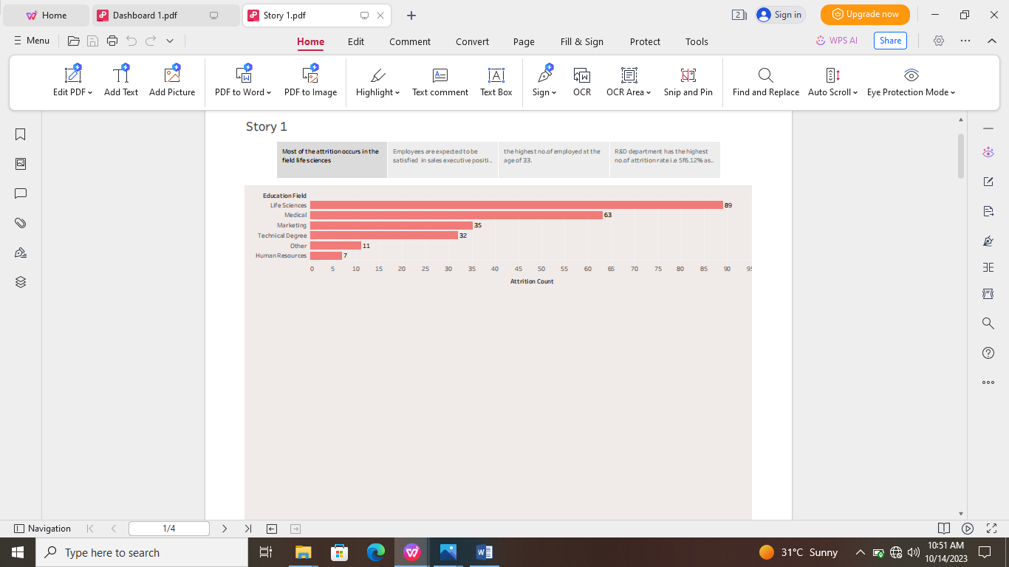

**4 ADVANTAGES & DISADVANTAGES**

*With a scorecard, HR leaders can assess the department's performance in their way and within a set structure that can be understood across the organization. Here are the top four benefits of an HR scorecard:*

1. **Gives structure to the strategy**

*A scorecard helps keep the goals at the center, uses specific parameters to track progress, and follows initiatives for monitoring actions.*

2**. Improves performance reporting**

*The HR scorecard can come in handy for designing performance reports and dashboards, ensuring the focus remains on critical strategic issues and helping the HR department monitor the execution of its plan.*

3. **Makes it easier to communicate the strategy**

*Having a scorecard takes the guesswork out of trying to understand everyone's responsibilities in the team and gets the entire department synced up under one structure. This also gives a much clearer picture of HR projects and initiatives.*

4. **Connects every HR employee to organizational goals**

*An HR scorecard allows HR personnel to individually align their goals across the department and organization. When every employee sees a greater purpose behind the goals and objectives they are aiming to achieve; it engages them even more in their work.*

**Disadvantages of an HR balanced scorecard**

*While there are so many benefits to deploying an HR scorecard, there are potential roadblocks you should be aware of:*

*Even though there are many HR scorecard templates you can use, the framework must be customized to suit your business requirements. This can be time-consuming and tedious - especially for first-time users.*

*HR scorecards can be overly complicated to understand despite there being many case studies and resources to read from.*

*HR scorecards usually require managers to report information, which can cause some resistance and even delays.*

**5 APPLICATIONS**

*Data collection is the process of gathering and measuring information on variables of interest, in an established systematic fashion that enables one to answer stated research questions, test hypotheses, and evaluate outcomes and generate insights from the data.*

**6 CONCLUSION**

*The HR scorecard is a tool that helps measure, manage and improve the role of the HR function within an organization.*

*HR metrics and KPIs or HR deliverables are measures using the HR scorecard. This data is also to predict the potential growth of the organization*.

**7. FUTURE SCOPE**

*The tableau HR scorecard is a framework designed to measure and evaluate the success of talent management strategies within an organization.*

*Thank you *